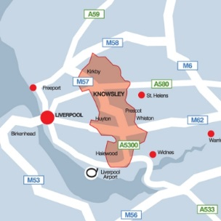

**Using Knowsley Town Centers**

 Would you go if it was easier to use?

Everyday Once a month

Once a week Once a year

Never

1. Where is your town centre?

2. How often have you visited your town centre in the last 6 months?

Halewood Kirkby

Huyton Prescot

Can you tell us about where you shop in Knowsley?





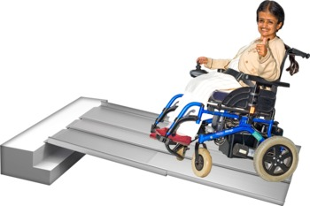



3. How does this affect you?

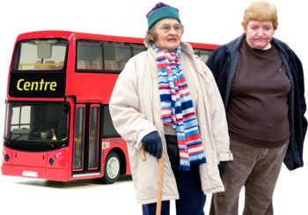

4. How do you get to your town centre?

Walk Taxi

Wheelchair/Scooter Bus

Car Cycle

Other

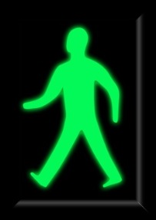

This question is about **‘getting around’**

5. Please tick if any of the following have happened to you

Narrow pavements Difficulty parking (including paying)

No dropped kerbs Poor lighting

Temporary obstacles

Difficult to get into shops

Difficulty moving around in shops

Getting to things you can buy



Anti-Social behaviour or hate crime

Not listening when you ask to improve things

Impatient staff

The staff do not know about accessible facilities

Negative attitude from other customers

Patronising staff

Stock and services are not suitable for disabled people

Unhelpful staff

Other

This question is about **‘other people’**

6. Please tick if any of the following have happened to you

No accessible changing rooms

No accessible toilets

Goods on floor restricting movement

No safe crossings

Other



This question is about **‘finding your way’**

7. Please tick if any of the following have happened to you

Cannot read menus or price tags

No easy read information

No hearing loops or staff not knowing how to use them

No signs for accessible facilities

Poor directions and signs

Shop offers and promotions not relevant to people with access needs

Other



8. What is one thing you would change to encourage you to use your local town centre more?



9. Can you tell us about a positive experience you have had visiting a town centre? For example: a place that is easy to access or has good customer service?



10. Is there anything we have missed that you think is important?



Content created by the members of the Knowsley Physical and

Sensory Impairment Partnership Board in partnership with the Knowsley Being Involved Group