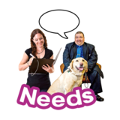 | A JSNA finds out the health and wellbeing needs of community members living in Knowsley
 | It is used to shape health and wellbeing services
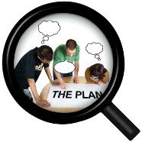  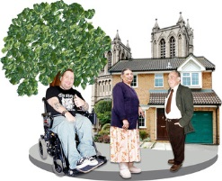 | They use research and data and engage with service users and community members to find out what the needs are of community members
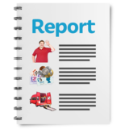 | Some of the reports have already been published
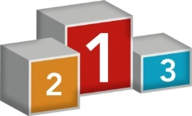 | We need to identify a small number priorities
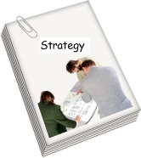 | This will inform the work of the Joint Health and Wellbeing Strategy
 | There are 13 questions in the survey
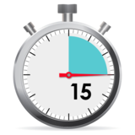 | It should take about 20 minutes
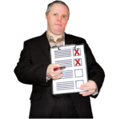 | Put an ‘X’ in ONE box on the right hand side for your answer
Question 1 | From your experience and local knowledge what do you feel are the top THREE priorities in your community (these do not have to be from the above lists)?
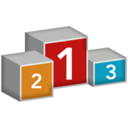 | 1
 | 2
 | 3
Question 2 | Lifestyle
 | What do you think is the most important?
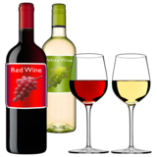 | Alcohol –Reducing excessive alcohol drinking and its impact on health and related crime.
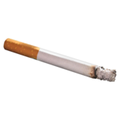 | Smoking and Tobacco - Reduce smoking to reduce smoking related diseases and health issues.
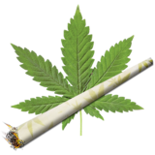 | Substance Misuse - Reducing levels of legal and illicit drug use and deal with its impacts.
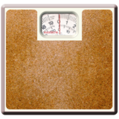 | Obesity and Healthy Weight - Reducing levels of obesity and overweight adults and children.
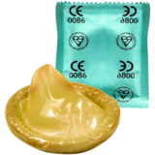 | Sexual Health - Reduce prevalence of sexually transmitted diseases and other sexual health problems.
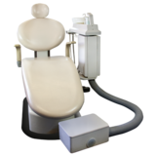 | Oral Health - Improve dental health, especially in children.
Question 3 | Medical Conditions
 | What do you think is the most important?
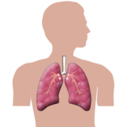 | Breathing Disease - Reducing breathing diseases, including Asthma and COPD.
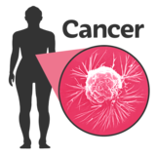 | Cancer - Reducing cancer rates and improving early detection and outcomes for those affected.
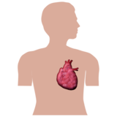 | Heart Disease and Stroke – making things better for people and reducing the numbers of those affected.
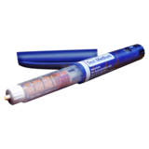 | Diabetes - Reducing numbers with diabetes and making things better for people with diabetes
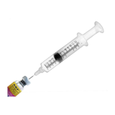 | Health Protection - Protecting people from harm, including through immunisations and vaccinations.
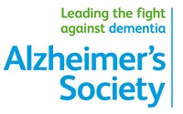 | Dementia - Supporting increasing number of individuals with dementia and their carers
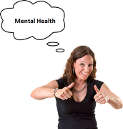 | Adult Mental Health and Wellbeing - Reducing mental illness and improving wellbeing and mental health outcomes.
Question 4 | Adults
 | What do you think is the most important?
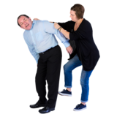 | Domestic Abuse - Reducing domestic abuse and making things better for people affected
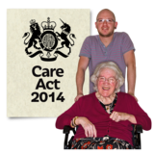 | Adults and Young Carers - Supporting carers of individuals with particular needs.
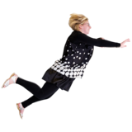 | Falls - Reducing falls, especially in elderly.
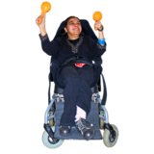 | Physical Disability - Supporting adults with physical disabilities.
 | Learning Disabilities - Supporting adults with learning disabilities.
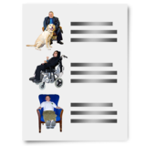 | Vulnerable Adults – Making sure adults at risk are safeguarded.
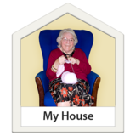 | Older People and Adult Social Care - Reducing admissions for residential care.
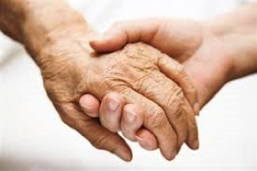 | End of Life - Supporting people to die with dignity and respect.
Question 5 | Children
 | What do you think is the most important?
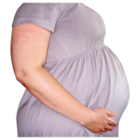 | Maternity - Improving pregnancy and birth outcomes.
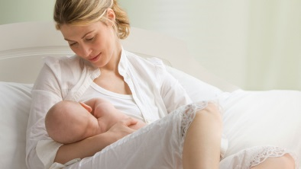 | Breastfeeding - Increase numbers of mums breastfeeding.
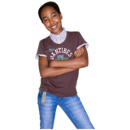 | Looked After Children – Making things better for children looked after by local authority or foster carers.
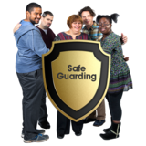 | Children at Risk and in Need – Making sure that children at risk are protected from harm.
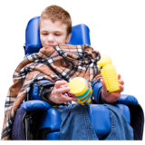 | Children with Disabilities - Supporting children with physical and learning disabilities and autism.
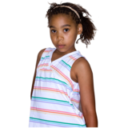 | Children in Poverty - Reduce child poverty and its impacts on children.
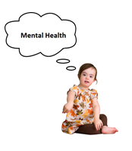 | Children's Mental Health - Improving mental health and wellbeing in children.
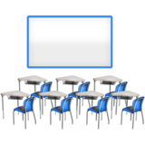 | Education Attainment and Attendance - Improving educational attainment, attendance and outcomes.
Question 6 | Wider determinates of health
 | What do you think is the most important
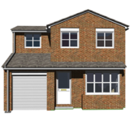 | Housing - Reducing poor housing and its impacts like overcrowding, poorly heated and unsafe.
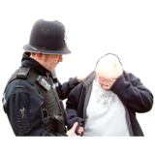 | Crime and Threats - Reducing crime and fear of crime and the impacts of all crime.
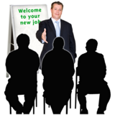 | Employment and Unemployment - Reducing impact of being out of work, or of poor and low quality and insecure jobs.
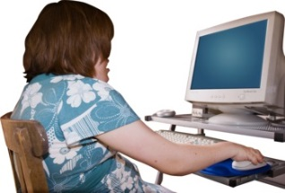 | Digital Inclusion - Improving digital access and reducing social exclusion.
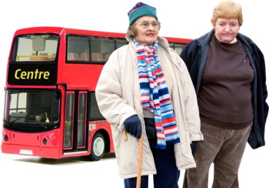 | Transport - Improving access to travel across the borough and reducing social isolation.
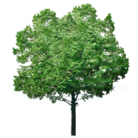 | Environment - Improving physical environment across the borough.
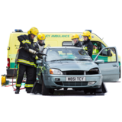 | Accidents - Reducing accidents in the home, work, roads and community.
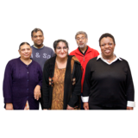 | Protected Characteristics Groups - Supporting the needs of Black and Minority Ethnic Groups, Military Veterans and Lesbian, Gay & Transgender.
Question 7 | Do you have any comments / feedback about the Joint Strategic Needs Assessment (JSNA) prioritisation?

Question 8 | Please tell us which of the following groups best describes you?
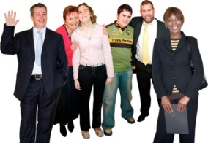
 | GP
 | Primary Care
 | Local Authority
 | Acute Trust (Hospital)
 | Clinical Commissioning Group
 | Member of Public
 | Councillor
 | Community or Voluntary Organisation
 | Other – can you tell us more?
 | The following questions are slightly more personal about you. All responses are strictly confidential and results will NOT identify individuals.
Question 9 | What is your gender?
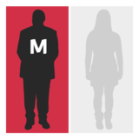 | Male
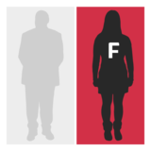 | Female
 | Do not want to say
Question 10 | What age group do you belong to?
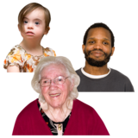
 | 18-24
 | 25-34
 | 35-44
 | 45-54
 | 55-64
 | 65-74
 | 75+
 | Do not want to say
Question 11 | Do you consider yourself to have a disability or long-term health condition?
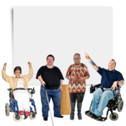
 | Yes
 | No
 | Do not want to say
Question 12 | What is your disability?
 | Prefer not to say
Question 13 | To which ethnic group do you belong?
Asian or Asian British: | Bangladeshi |  | Indian
Asian or Asian British: | Pakistani |  | Other Asian background

Black or Black British: | African |  | Other Black background
Black or Black British: | Caribbean
Chinese, Polish or any other ethnic group: | Chinese |  | Other Ethnic Group
Chinese, Polish or any other ethnic group: | Polish
Mixed Heritage: | White and Asian |  | White and Black African
Mixed Heritage: | White and Black Caribbean |  | Other mixed heritage background
White: | British |  | English
White: | Irish |  | Scottish
White: | Welsh |  | Other White background
Prefer not to say:

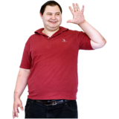 | Thank you for participating in this survey, your time and comments are appreciated.
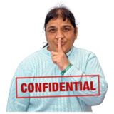 | All information is confidential and NO individuals will be identified in the results.

