Mental Health & Me Writing Competition
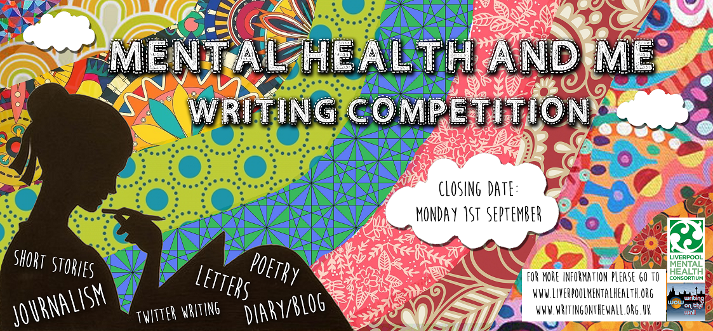
Literature’s love affair with the mind is an age-old tradition where creativity has always been closely entwined with mental distress, yet the subject of mental health is still widely considered a taboo subject. We hope that this competition will challenge the stigma around mental distress by giving entrants the opportunity to explore this topic using traditional &/or alternative forms of writing.
Has mental distress affected you or someone close to you? Are you particularly interested in the subject of mental health? Are you a carer? Have you worked with people experiencing mental distress & want to share your experience? If the answer’s yes, we’d love to hear from you!
Liverpool’s Mental Health Consortium, in partnership with Writing on the Wall, is launching a writing competition to mark World Mental Health Day on Friday 10th October 2014. We are inviting you to send us an original written response to the expression ‘Mental Health & Me.’ You can send us a poem, a short story, a diary piece or blog post, a letter, a piece of journalism, or even a tweet; yes - a tweet!
Literature is no one’s private ground; literature is common ground; let us trespass freely & fearlessly & find our own way for ourselves – Virginia Woolf

Mental Health & Me Competition Rules

The competition is based around the theme ‘Mental Health & Me’, & will be judged around 6 categories:
- Poetry
- Short stories
- Diary/Blog
- Letters
- Journalism
- Tweets
For each category, there will be a judging panel comprising of professional writers, booksellers, librarians, & people with personal experience of mental distress. The winners of each category will form the shortlist from which the overall winner will be selected. For specific guidelines on each category, please see Submission Details.
So what will I win?
The overall champion of all 6 categories will win the special WoW & LMHC trophy, & book tokens from our independent book store, News from Nowhere! AND - The winners & runners-up from each category (including the Top 10 Tweets) will be included in an anthology, published by Liverpool Mental Health Consortium & Writing on the Wall. Once the winner has been announced, free hard copies will be available to everyone included in the anthology, & free copies available online.
On the evening of World Mental Health Day on 10th October, all shortlisted entrants will be invited to a celebratory event at Liverpool Central Library & will be given the opportunity to read their work to the public. And between you & me ... there will be a special guest to be announced at the event to judge the winner ... watch this space!
When is the deadline?
The competition is now open, from 11th July 2014, & closes at 5pm Monday 1st September 2014. No entries will be accepted after this date, so make sure you don’t miss out!
Where do I submit my entry?
You can submit your entry via email at competition@liverpoolmentalhealth.org
Important:
Please ensure you submit your attachment (World Files only) & your entry form. You can also send your entry by post (with the entry form) - See details on form
Submission Details
- Entry to the competition is free
- Entrants must be 18 & over
- Entrants must be a resident in Merseyside
- Entries must be typed or handwritten in English
- Entries must be on the theme of ‘Mental Health & Me’
- Entries must be original work of the author
- Entries must not have been published or entered in other competitions
- Poetry must not exceed 50 lines
- Short Stories must be between 500 & 1,500 words
- Diary/Blog entries must not exceed 500 words
- Letters must not exceed 750 words (it can be addressed to anyone, but must be signed by the author)
- Journalism must not exceed 750 words
- Tweets must not exceed 140 characters
- Entrants can enter more than one category, but must not submit more than 1 entry for each category
- Please do not put your name on your work - we only require it for the submission form
- By entering, you are agreeing to have your work shared/included in media or published in the anthology
- Copyright stays with the author
- Successful entrants will be notified by 6th October 2014
- The judges’ decision is final, & feedback regarding unsuccessful applications will not be provided

Mental Health & Me
Name:
Date of Birth:
Gender: | Male Female Unspecified
Postal Address:
Email Address:
Home No.
Mobile No.
Title of Submission Piece
Submission Category
(Please tick the appropriate box)
Short Stories |  |  | Diary/Blog
Letters |  |  | Tweet
Poetry |  |  | Journalism
Submission Form

Please complete this submission form & enclose it in your email along with your entry, & send it to competition@liverpoolmentalhealth.org
Alternatively, you can post your entry & submission form to: Mental Health & Me, c/o Writing on the Wall, Kuumba Imani Millennium Centre, 4 Princes Road, Toxteth, Liverpool, L8 1TH
Please note the closing date for this competition is 1st September at 5pm. No entries will be accepted after this time.

