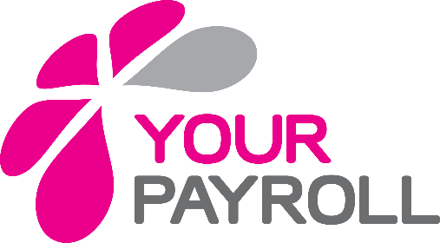
New Starter Form

Instructions for employees
As a new employee your employer needs the information on this form before your first payday to tell HMRC about you and help them use the correct tax code. Fill in this form then give it to your employer.
❺ Home address
Postcode

County
Employee’s personal details
❶ Last name

❷ First names (s)
Do not enter initials or shortened names such as Jim for James or Liz for Elizabeth
❻ National insurance number

❸ Are you male or female?
Male ☐ Female ☐ Title:
❼ Employment start date DD MM YYYY
❹ Date of birth DD MM YYYY

⓫ Bank account number

Sort code

❽ Your email address ❾ Your telephone number
This is required to access your secure online pay portal

❿ Bank details

Account name
Bank

⓬ Your employer details
Name

Address

Postcode

19
Employee statement
⓭You need to select only one of the following statements A, B or C
A ☐ This is my first job since last 6 April and I have not been receiving taxable Jobseeker’s Allowance, Employment and Support Allowance, taxable Incapacity Benefit, State or Occupational Pension.
B ☐ This is now my only job but since last 6 April I have had another job, or received taxable Jobseeker’s Allowance, Employment and Support Allowance, taxable Incapacity Benefit. I do not receive a State or Occupational Pension.
C ☐ As well as my new job, I have another job or receive a State or Occupational Pension.

Student Loan Plans
you will have a Plan 1 Student Loan if:
- You live in Scotland or Northern Ireland when you started your course, or
- You lived in England or Wales and started your course before September 2012.

You will have a Plan 2 Student Loan if you lived in England or Wales and started your course on or after 1 September 2012.
⓰ What type of Student Loan do you have?
Plan 1 ☐
Plan 2 ☐

⓱ Did you finish your studies before the last 6 April?
Yes ☐
No ☐
For further guidance on repaying Student Loans go to www.gov.uk/new-employee/student-loans
⓮ Student Loan
Do you have Student Loan which is not fully repaid
Yes ☐ if yes, go to question 15
No ☐ If no, go to question 17
⓯ Are you paying your Student Loan direct to the Student Loans Company by agreed monthly payments?
Yes ☐ If yes, go to question 17
No ☐ If no, go to question 16

Name
Date (DD MM YYYY)
⓲ Your Signature

20
By signing or typing your name above you are declaring the information on this form is a true and honest account of your circumstances.

